Design Patterns Project
Online Food Ordering System
Builder Design Pattern
Course | Programming Design Patterns
Team Members | Ahmad Odeh, Mohammed Ziad, Ayham Abulawi, Rasmi Kamel
Instructor | Dr. Issam Jebreen
Date | 3 August 2026

1. Project Idea
Our project is a simple online food ordering system written in Java. We used the Builder Design Pattern to create different types of orders in an organized way. The system can build a delivery order or a pickup order using the same building steps.

2. The Problem
At the beginning, we noticed that creating an order directly can make the code longer and harder to change. An order contains several details such as the customer name, address, meal, quantity, and payment method. Also, delivery and pickup orders may use the same steps but produce different values.
Our main goal was to separate the process of building the order from the final Order object. This makes the code easier to understand and allows us to add another order type later.

3. Project Requirements

3.1 Functional Requirements
- Create a delivery order.
- Create a pickup order.
- Set the customer name, address, meal, quantity, and payment method.
- Use the same construction steps for different order types.
- Display the completed order details.

3.2 Non-Functional Requirements
- The code should be simple and easy to read.
- Each class should have one clear responsibility.
- The design should make it easy to add a new order type.
- The classes should have low dependency as much as possible.

4. Design Patterns We Considered
We compared Builder with Factory Method because both patterns are related to object creation.
Point | Builder | Factory Method
Main idea | Builds an object through a number of steps. | Creates one object type through a factory method.
Best use | When the same steps can create different representations. | When the client needs one of several product classes.
Our project | The Director uses the same steps for Delivery and Pickup orders. | It would create an order type, but it would not organize all building steps.
Decision | Selected. | Not selected.

5. Why We Selected Builder
We selected Builder because our two order types follow the same construction process. The OrderDirector controls the steps, while each Concrete Builder decides the values that will be placed in the final Order. This matches the classic Builder structure explained in the course material.

6. How Builder Is Used in Our Code
Pattern Role | Class in Our Project | What It Does
Product | Order | Stores the final order information.
Builder | OrderBuilder | Defines the building steps.
Concrete Builder | DeliveryOrderBuilder | Builds a delivery order.
Concrete Builder | PickupOrderBuilder | Builds a pickup order.
Director | OrderDirector | Calls the building steps in order.
Client | Patternnproj | Selects a builder and runs the program.

7. UML Class Diagram
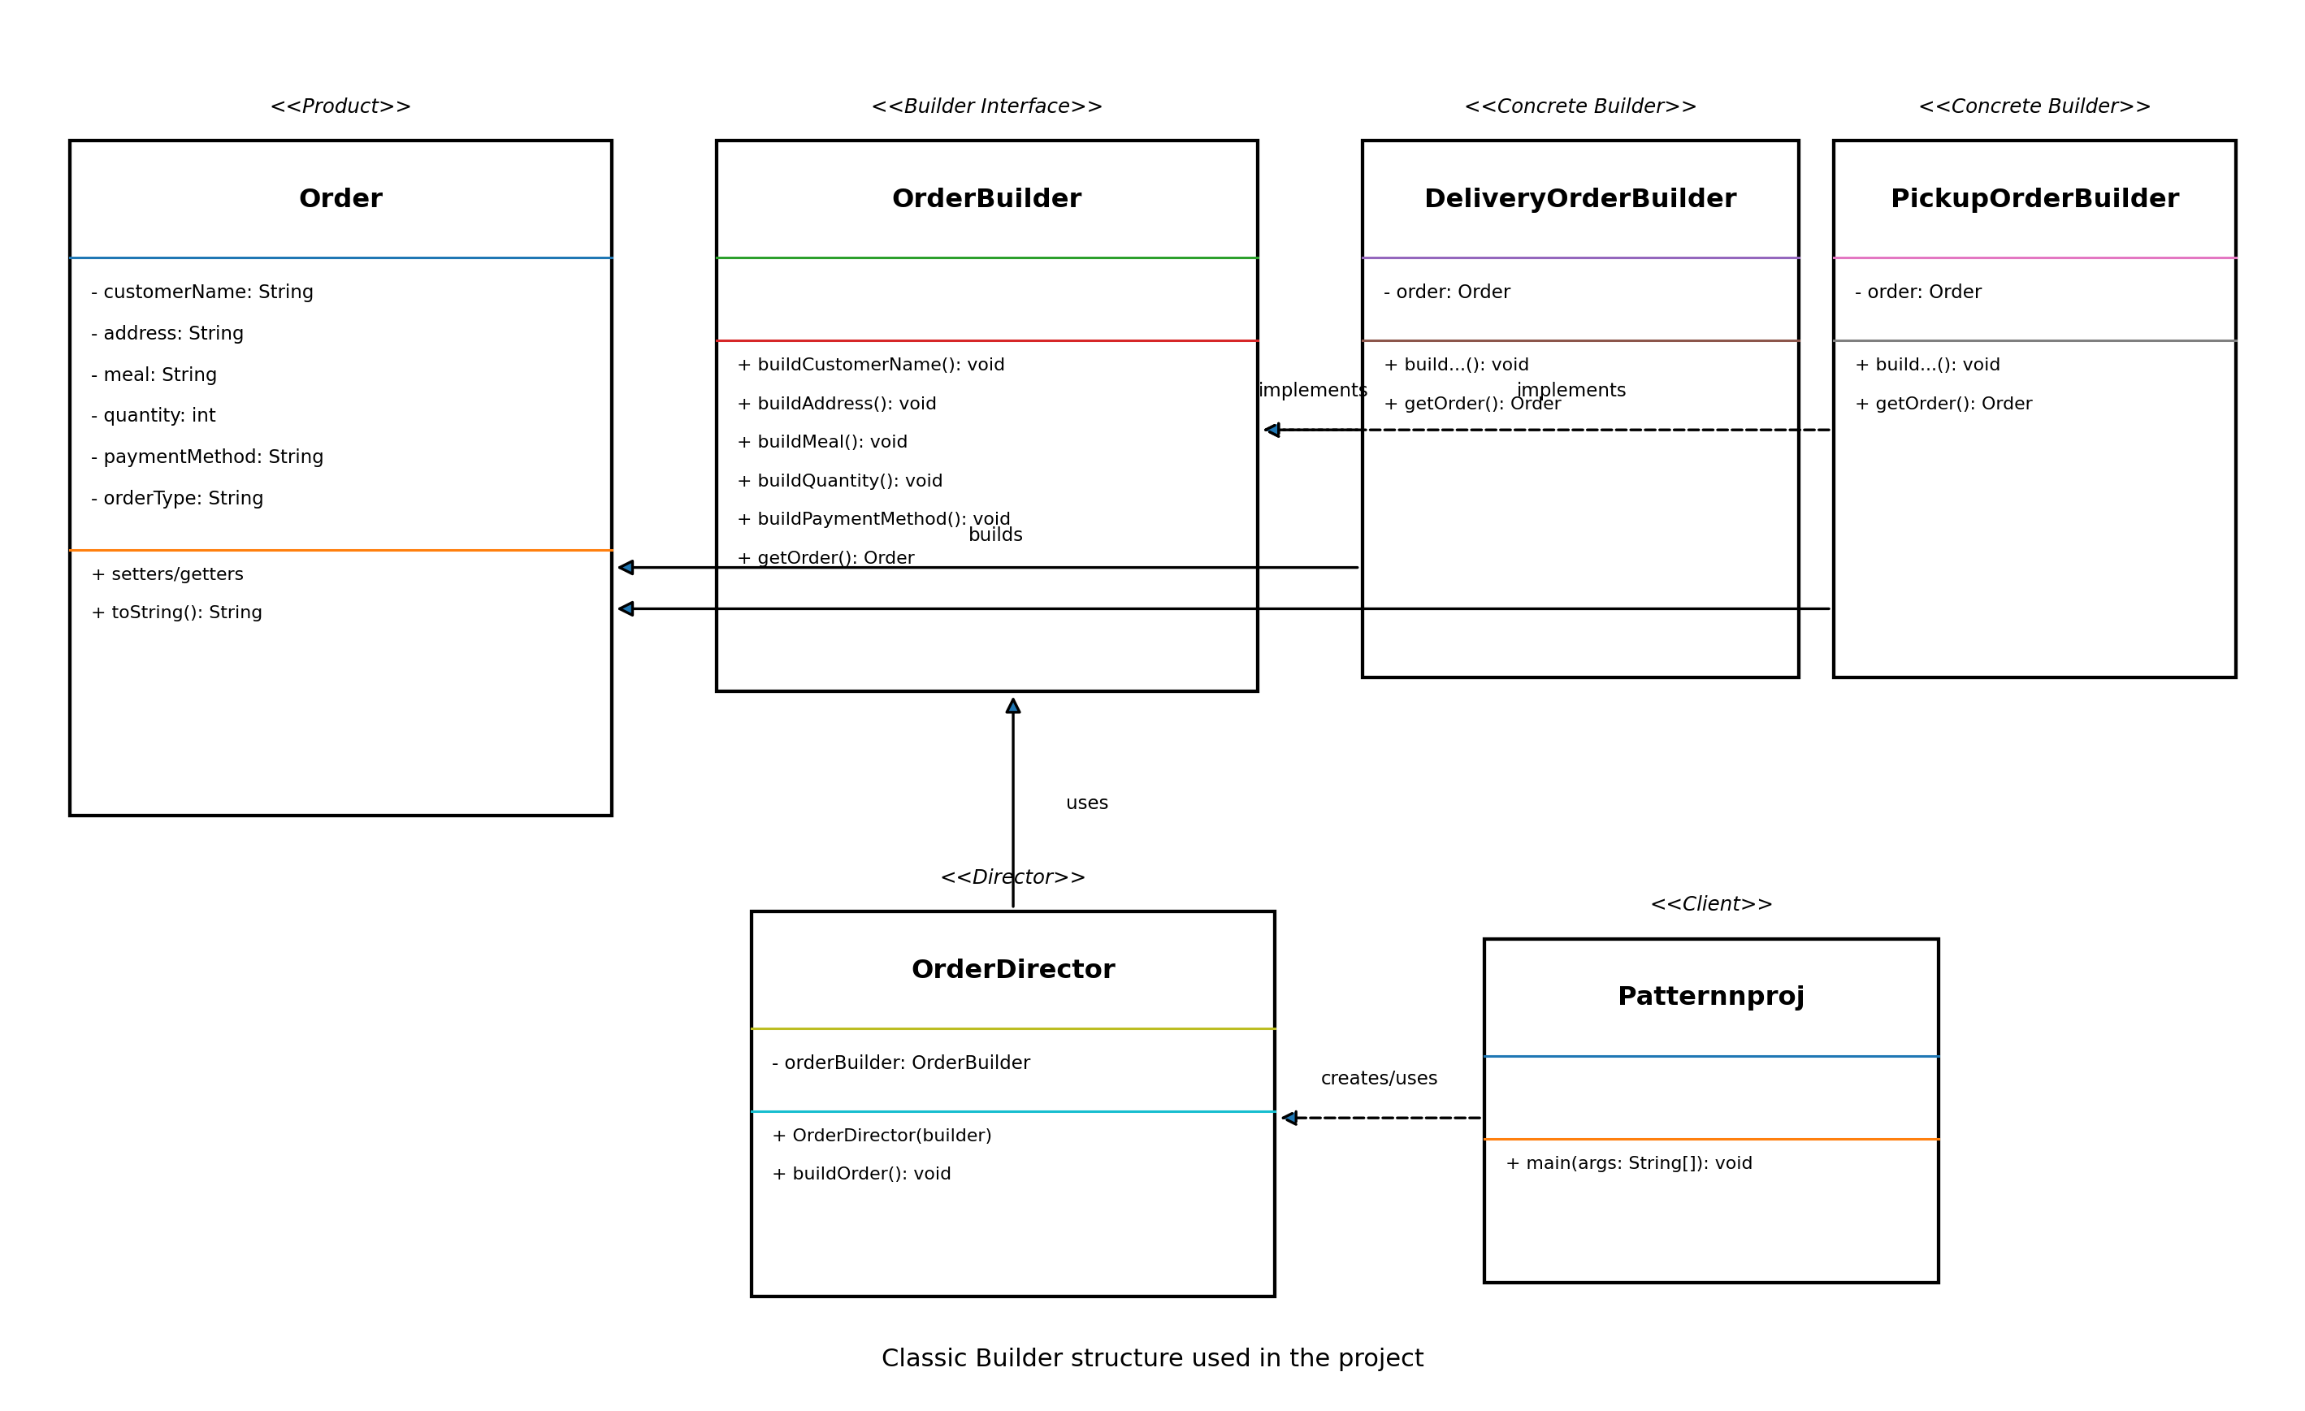
Figure 1. UML diagram of our Builder Pattern implementation.
The diagram shows that DeliveryOrderBuilder and PickupOrderBuilder implement OrderBuilder. OrderDirector works with the OrderBuilder interface, so it does not depend on one specific builder. The client selects the builder, asks the director to build the order, and then receives the final Order.

8. Project Files
- Order.java - the Product class.
- OrderBuilder.java - the Builder interface.
- DeliveryOrderBuilder.java - builds delivery orders.
- PickupOrderBuilder.java - builds pickup orders.
- OrderDirector.java - controls the order-building steps.
- Patternnproj.java - contains the main method and runs the project.

9. Program Flow
1. The client creates a DeliveryOrderBuilder or PickupOrderBuilder.
2. The selected builder is passed to OrderDirector.
3. OrderDirector calls the building methods in the correct order.
4. The Concrete Builder fills the Order object with its own values.
5. The client gets the completed Order and prints it.

10. Testing
Test | Expected Result | Result
Build a delivery order | Shows delivery order information. | Passed
Build a pickup order | Shows pickup order information. | Passed
Change the selected builder | The Director works without changing its steps. | Passed

11. GitHub and Team Work
We used a GitHub Project Board to divide the tasks between the team members and track the progress.
GitHub Repository Link: https://github.com/MDRVV06/online-food-ordering-builder
GitHub Project Board Link: https://github.com/users/MDRVV06/projects/1/views/1

12. AI Support Used in the Project
We used an AI assistant during the review stage. We asked it to check whether our Builder structure was correct, compare Builder with Factory Method, and suggest improvements for the UML and documentation.

12.1 Prompt Used
Review our Java Builder Pattern project for an online food ordering system. Check the roles of Product, Builder, Concrete Builder, Director, and Client. Compare Builder with Factory Method and suggest a UML diagram.

12.2 How It Helped Us
- It helped us check the pattern roles.
- It helped us organize the comparison between Builder and Factory Method.
- It suggested improvements to the UML and documentation.

12.3 Our Team Decision
We accepted the suggestions that matched our code and course material. We changed the wording and examples to fit our own project. We did not add features such as databases, live tracking, or real payment because they are outside our project scope.
AI Response Screenshot: Attach the screenshot required by the instructor.

13. Conclusion
In this project, we applied the classic Builder Design Pattern to an online food ordering example. The pattern helped us separate the building steps from the final Order object. It also allowed us to create delivery and pickup orders using the same Director. The project can be extended later by adding new Concrete Builders without changing the main building process.

